Narrative for Covid part of project:

Note: Please don’t include my name and slide number – just trying to give an idea of what I was thinking about. Thank you!

Hypothesis:

Based on the influence of lockdowns in intensity of Covid-19 epidemics, we expect to see that there is a positive effect on stabilizing climate change.

Null Hypothesis:

Based on the influence of lockdowns in intensity of Covid-19 epidemics, we were unable to discern any trend of climate change stabilization

Karen Slide 1



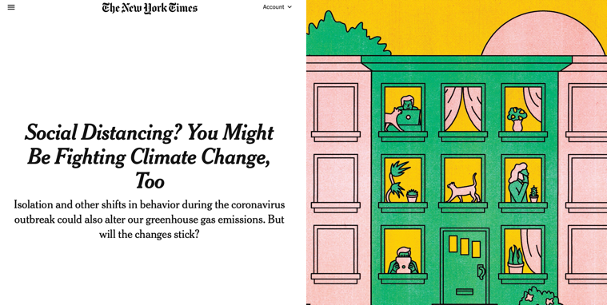

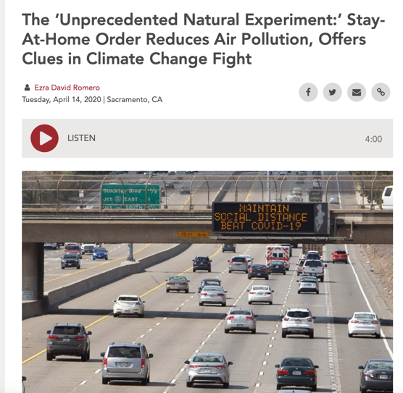



Karen Slide 2



Karen Slide 3

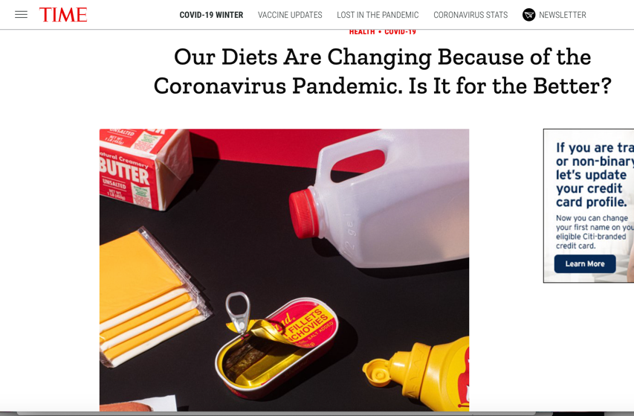

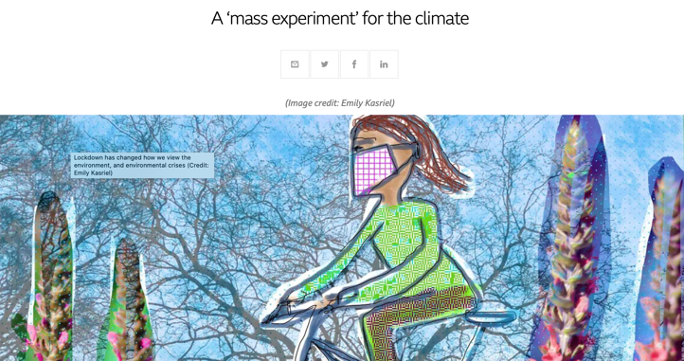

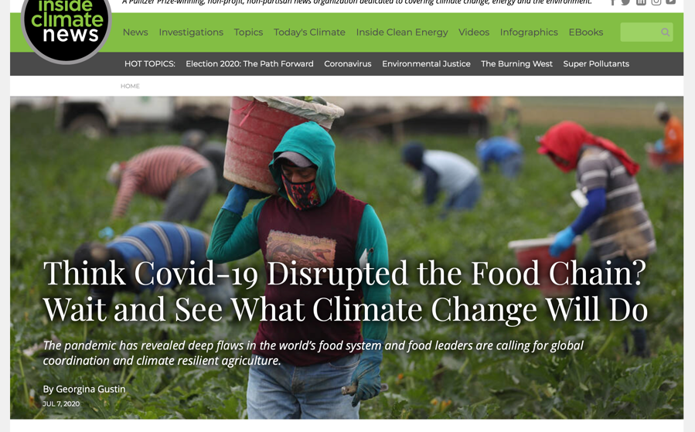



Karen Slide 4

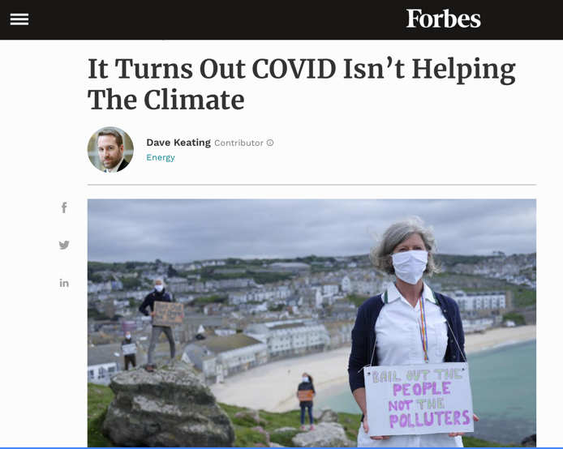



Karen Slide 5



